### Digital Portfolio

STUDENT NAME: Nirmal Kumar R

REGISTER NO AND NMID:

astvu300tvu30030018033 DEPARTMENT: B.sc.Computer Science COLLEGE: Thiruvalluvar University

 1

## PROJECT TITLE



Digital Portfolio Using HTML,CSS ,

Java script

2

# AGENDA



1. Problem Statement
2. Project Overview
3. End Users
4. Tools and Technologies
5. Portfolio design and Layout
6. Features and Functionality
7. Results and Screenshots
8. Conclusion
9. GitHub Link

3

3/21/2024 **Annual Review**

## PROBLEM STATEMENT

**Define the problem**: Explain the need for a digital portfolio in today's digital age.

**Why it's important**: Address the gap for students, professionals, or businesses needing a modern, interactive way to showcase their work, skills, and accomplishments.



 4



## PROJECT OVERVIEW

**Objective**: To create a comprehensive, easy- to-navigate digital portfolio for individuals to showcase their work or achievements online.

**Purpose**: Helping users professionally present their projects, skills, and experiences in a dynamic way.

**Scope**: This digital portfolio includes sections for education, experience, skills, projects, and contact details, and it can be easily updated.

 5

### WHO ARE THE END USERS?

**End Users**: Students, professionals, job seekers, and freelancers.

**Needs**: A platform for individuals to showcase their personal projects, resumes, portfolios, and achievements to prospective employers or clients.

**Pain Points**: Traditional paper resumes and portfolios are static and don't offer interactivity or instant updates.

6



**TOOLS AND TECHNIQUES**

**Frontend**: HTML, CSS, JavaScript (for interactive features and layout).

**Backend**: [If applicable] Node.js, PHP, or any backend technology you used.

**Other Tools**: GitHub (for code versioning), design tools like Figma or Adobe XD (for UI design).

7

**POTFOLIO DESIGN AND LAYOUT**

* Section Included
* Home / About Me
* Projects
* Skills
* Contacts
* Responsive layout (mobile + desktop view)

 8

# FEATURES AND FUNCTIONALITY

**Interactive Sections**: Dynamic project showcases, downloadable

resume, embedded video introductions, etc.

**Customizable Design**: Users can personalize their portfolios by adding content, changing themes, or updating sections.

**Mobile-Friendly**: Designed to be accessible on mobile devices for convenience.



## RESULTS AND SCREENSHOT 1

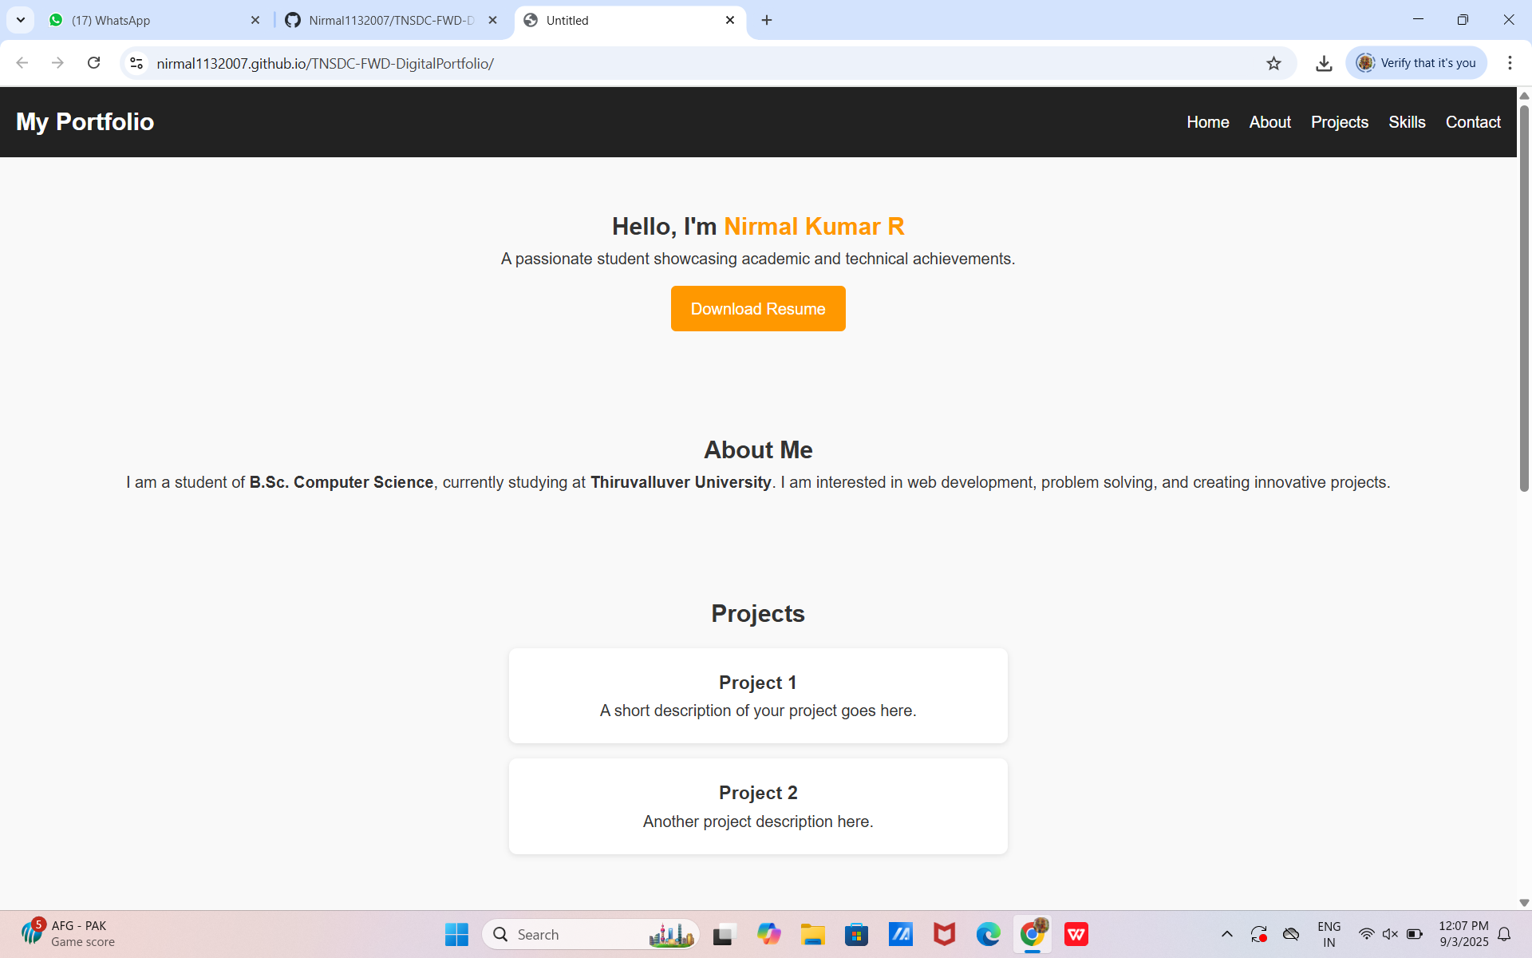

**RESULT AND SCREENSHOT 2**



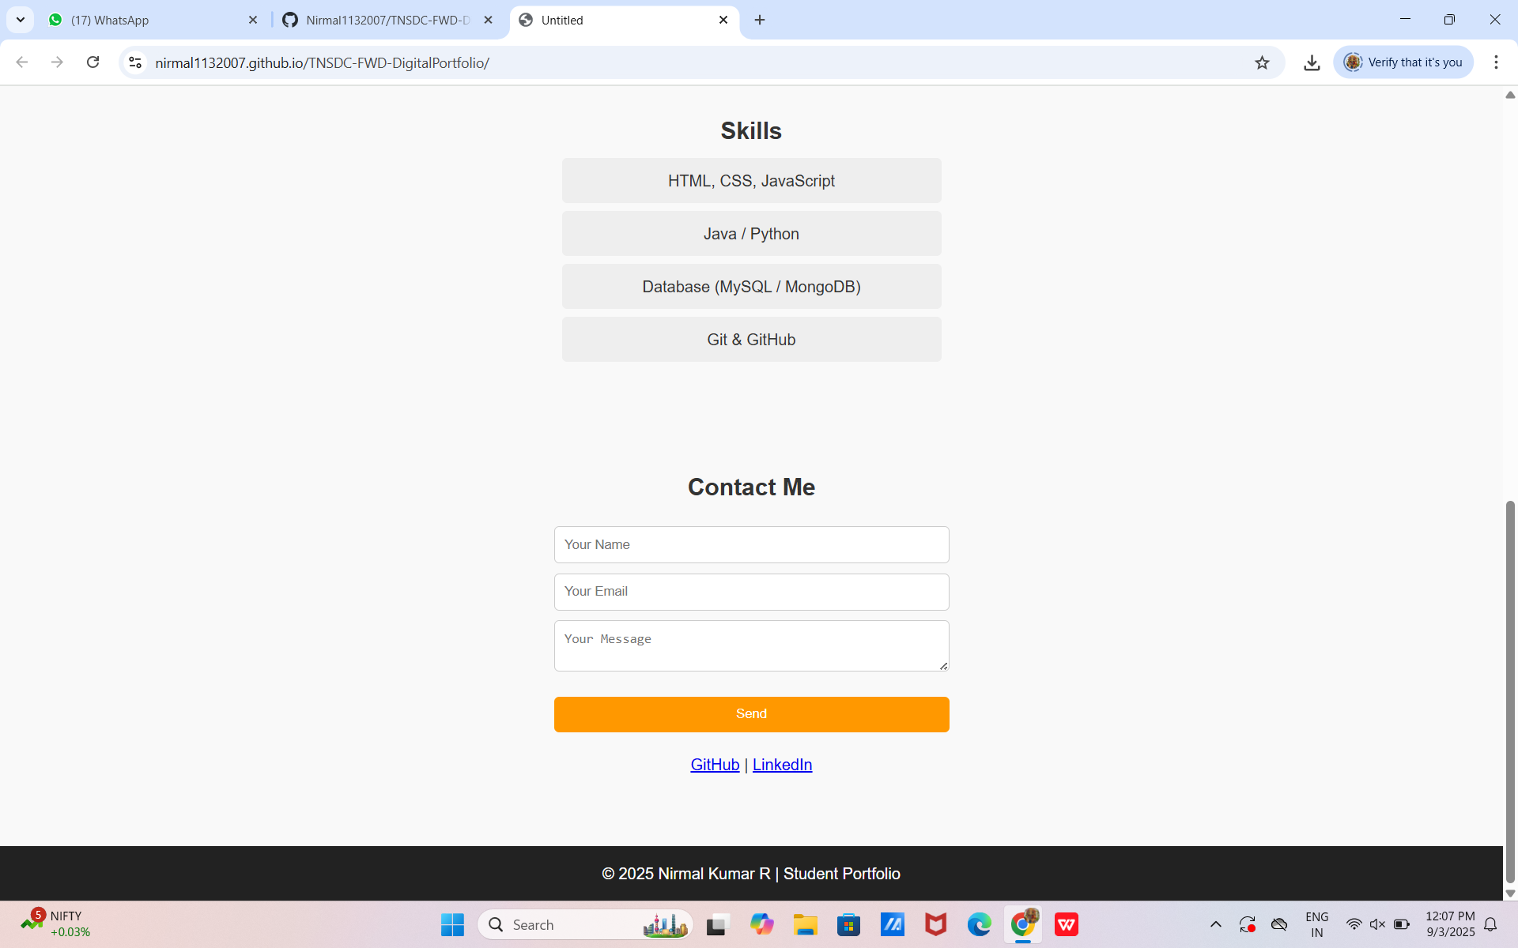

# CONCLUSION

**Key Takeaways**: Digital portfolios are a crucial tool for personal branding, offering a dynamic, interactive way to present achievements.

**Future Improvements**: Adding more interactive features, such as integrations with social media or work platforms, and expanding user customization options.

**Impact**: A digital portfolio enhances professional visibility and provides an organized, modern way to present one’s work.

 12

GitHub Link : https://github.com/Nirmal1132007/TNSDC-FWD-DigitalPortfolio.git